USER EXPERIENCE TESTING

**Group IIG**

| **Submitted By:** | **Submitted To:** |
| --- | --- |
| **Nischal Shrestha** | **Prajesh Shakya** |

**Date: 4th April, 2025**

# ABSTRACT

This report summarizes what I learnt from a user experience (UX) testing study conducted on the Group IIG website. The study aimed to evaluate the website’s usability, accessibility, and overall user satisfaction. The results highlighted key areas of strength and identified critical usability issues, including navigation complexities. Recommendations are provided to address the issues, focusing on improving the website’s efficiency, intuitiveness, and user engagement. Ultimately, this report aims to inform the optimization of the Group IIG website, ensuring a more positive and effective user experience.

# Group IIG

## Our Team

Each of the Board of Directors profiles looks great as it is and they are clickable as well. But those profiles are not linked with any page. When being clicked, if the profile card could direct the end-user to the specific BOD’s LinkedIn or Mail or any other contact platform, it would really be optimal and user friendly.



## Events and News

The Events and News section in the Homepage is displayed as below in the webpage.

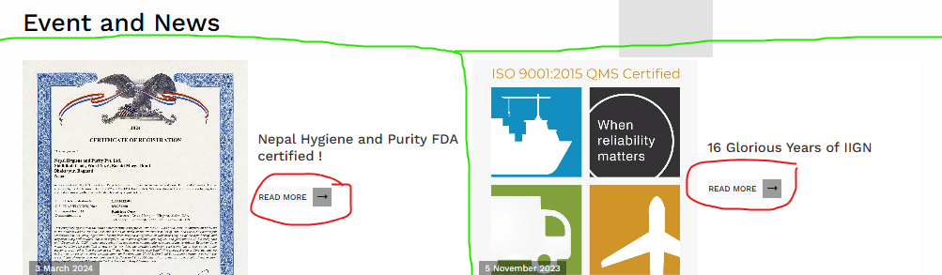

The green highlighted section entirely is a div for that specific news article which is clickable as well but only when we press “Read More” we are redirected to that article page.

This is not too optimal. If we could be redirected to an article, clicking anywhere on that event card, it would be more user friendly.

## Services

The Services page has logos of inhouse sister companies of IIG which are linked with their respective websites. But there is no title or mention of anything related to those companies. These are in fact also IIG Services but a title or figure caption could be more informational and easier from the end-user’s perspective.

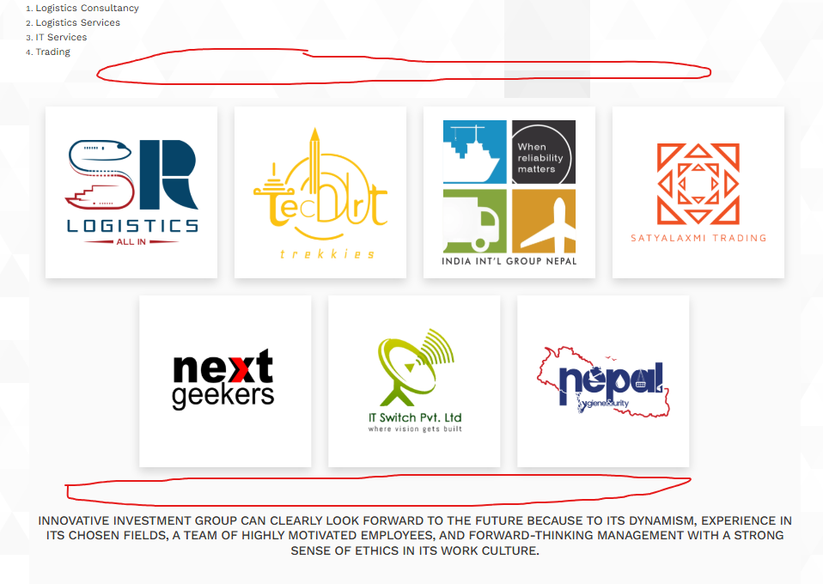

## News Page

This page looks really unpleasant. The black background covering the entire section is very unsettling. Contents or descriptions can be added in that dark background section. It would be much better if changing the entire UI for the Recent News section.

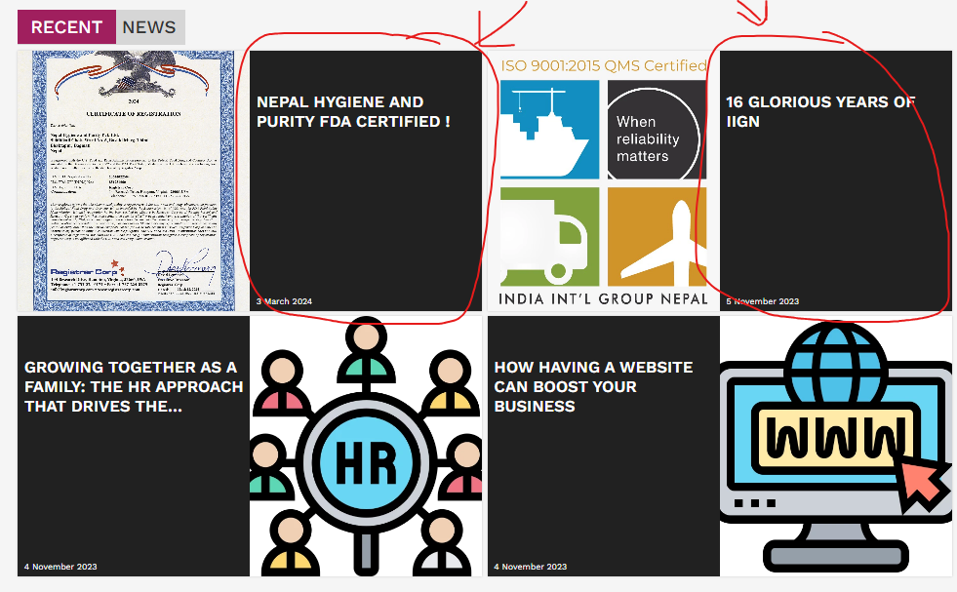

## All - News and Article

The news and articles are arranged in ascending order according to their published date. This makes the oldest article to be displayed in the first page. It would be better if it was vice versa since we can get the latest news in the beginning of the page. This is not a huge problem right now since there are only a limited number of articles. But when that news gets collected in a huge number, it will be a great hassle to view the latest news.

Also the last news is on 3rd March, 2024. This means this section has been inconsistent with its article upload. Time and again this section should be updated with the latest news article for better user interaction.

And finally, the page numbers for this section do not change when changing pages. It would be better if it showed which page we are on by displaying a different shade of color on the page numbers.

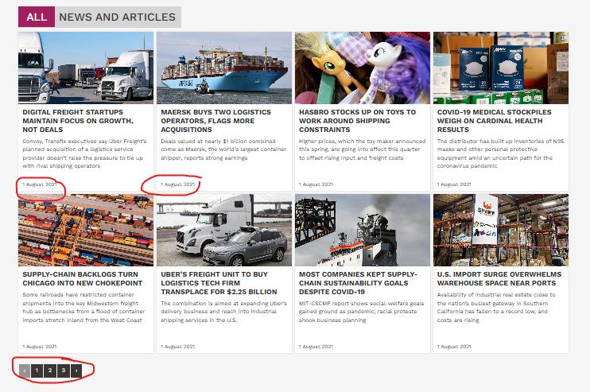

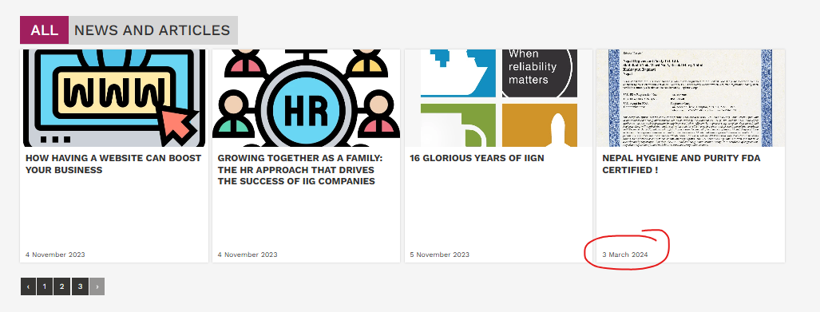

## Careers

The last item in the career section has a grammatical spelling error. “Junior” became “Jounior”. The user finding these type of small typo error is not well received.



## Contact Us

The “Submit” button here is black in color, which is similar if not the same shade of black as its background. So, it can be changed for more eye appealing UI color choices.



 